ISM 6225

Distributed Information Systems

Assignment 2 – Object oriented programming

Project Group 10

Meghana Chowdary P

Sri Sarada N

Prathyusha V

1. A link of Github repository :-

<https://github.com/srisaradanutakki/DIS_Assignment2.git>

1. A screenshot showing Program.cs running :-

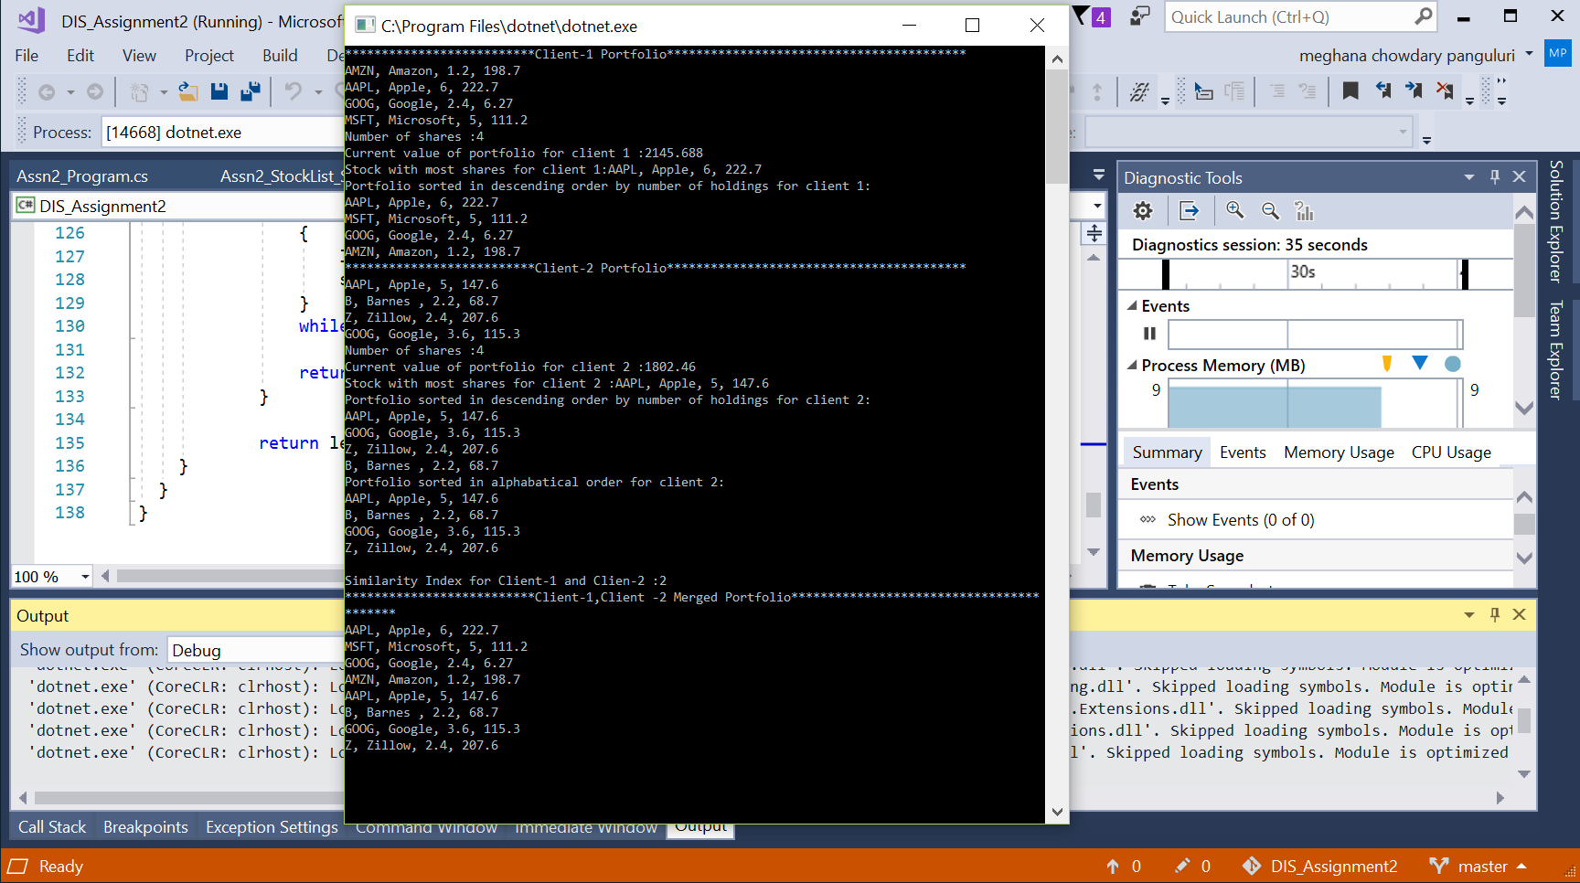

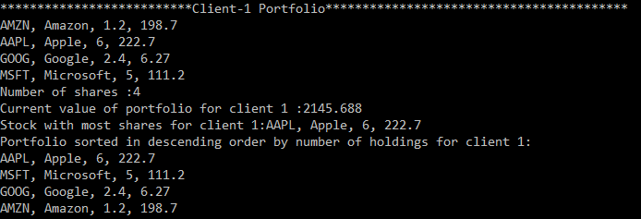

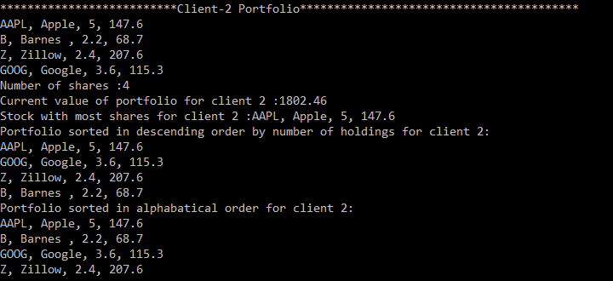

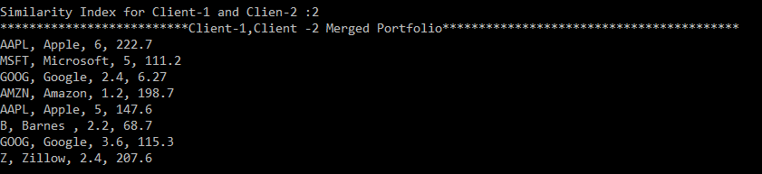

3.

The output from the command, for all team members. This shows the number of changes made by each Github ID. To run this command, open the command prompt (CMD), navigate to the folder containing the project repository (use the cd command), and type the command:

git log --author="<Github_ID>" --pretty=tformat: --numstat

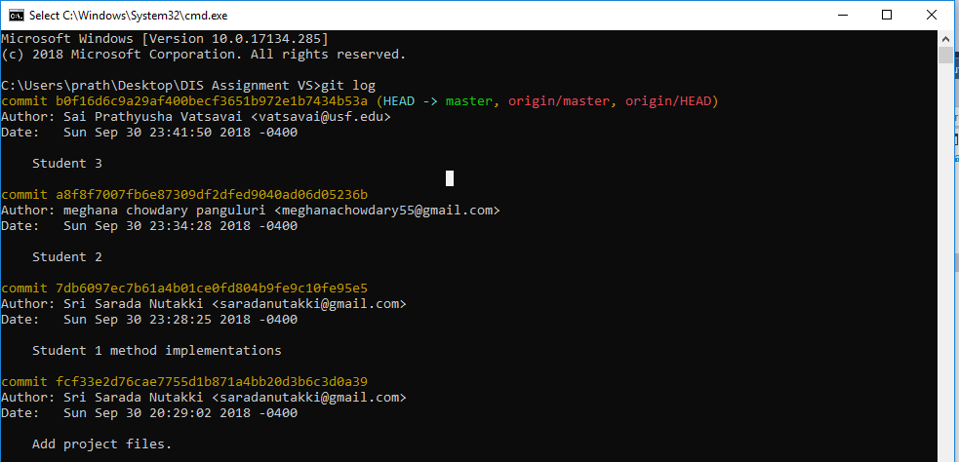

**Self-Reflection:**

1. We have spent for a total of 18 hours on this assignment for our respective tasks to implement.
2. We have implemented SortByValue, SortByName, MergeList, Similarity methods.
3. We learnt how the linked lists function and ways to access any object in linked list and iterate them.
4. We have learnt using Git Hub to create the repository and add the code to the repository
5. Apart from we learn how to work in team
6. It would be more helpful we get a chance to work on constructors and Inheritance